APPENDIX B: Validation timelines

Guide validation timescales

From School consideration to Panel Chair sign off normally a minimum of 8 weeks:
- 2 weeks for amendments & sign off from school event
- 3 weeks for panel to read papers
- 4 weeks for receipt of validation report
- 3-6 weeks for amendments & sign off from university event
+ add time for development
+ add time for Panel Chair review and sign off

Schools making proposals at a later stage should also be mindful of the potential impact on the recruitment cycle and student numbers on the initial intake:

Recruitment cycle
The UK Uni recruitment fairs typically run from September – November

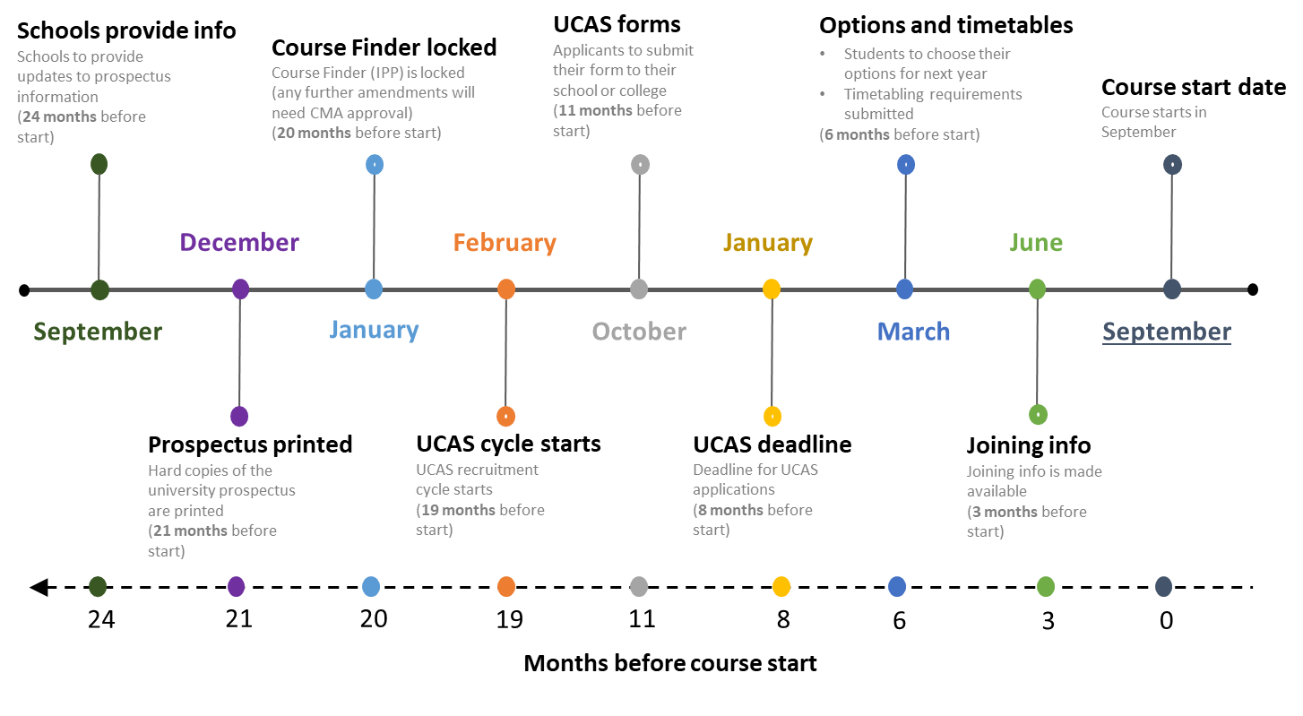
Month | Time before course start date | Marketing/Recruitment Cycle | Validation Cycle
September | 24 months | Work begins on prospectus and Course Finder. Schools to provide updates to prospectus information  UCAS applications open for entry the following year | Validation events.
October | 23 months |  | Validation events.
November | 22 months |  | Validation events.  Deadline for approval of courses for inclusion in the next years undergraduate prospectus.
December | 21 months | UG prospectus go to print for entry in 2 years’ time and no further additions can be made. | Validation events.  Registry and Academic Development request from schools’ information on new courses and course amendments for the following year’s validation schedule.  Schools begin to confirm courses for inclusion in the validation schedule.
January | 20 months | UCAS Applications deadline 25 January annually for majority of undergraduate courses commencing in September of that same year  Course Finder is locked and any further amendments will need CMA approval | Validation events.  Schools confirm courses for inclusion in the validation schedule.
February | 19 months | UCAS recruitment cycle for 2025/26 entry begins – national recruitment fairs run from February to July  (UCAS is not open for applications until September)  Changes will be reflected on Course Finder, subject area pages on the University website (which link the prospectus and Course Finder are also used for advertising campaigns and UCAS website | Validation events.
March | 18 months |  | Validation events.  Schools continue to confirm courses to be added as part of a rolling validation schedule
April | 17 months |  | Validation events.
May | 16 months |  | Schools continue to confirm courses to be added as part of a rolling validation schedule
June | 15 months | End of UCAS UG application cycle before Clearing begins. | Validation events.
July | 14 months |  | Validation events.
September | 12 months | UCAS applications open for entry in the following year  Work begins on UG prospectus and Course Finder for entry in 2 years’ time | Validation events.
October | 11 months |  | Validation events.
November | 10 months |  | Validation events.  Deadline for approval of courses for inclusion in the undergraduate prospectus.
January | 8 months | UCAS Applications deadline | Validation events.  Schools confirm courses for inclusion in the validation schedule.
February | 7 months |  | Validation events.
March | 6 months |  | Validation events.  Schools continue to confirm courses to be added as part of a rolling validation schedule
April | 5 months |  | Validation events.
May | 4 months |  | Schools continue to confirm courses to be added as part of a rolling validation schedule
June | 3 months | Joining information is made available | Final Validation events – no Tier 2 events will take place during July and August  Schools to submit all CMA Requests
September | 0 months | Course start dates

