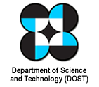
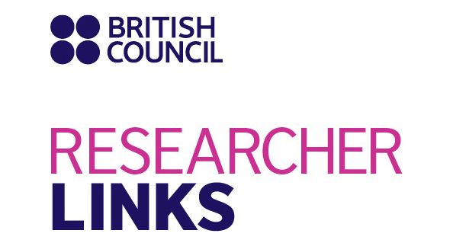

Call for participants at an International Workshop

- Workshop Title: LOCALISING STRATEGIES FOR MAKING CITIES RESILIENT TO DISASTERS

UK coordinator: Professor Dilanthi Amaratunga (Global Disaster Resilience Centre, University of Huddersfield, UK)
- Philippines coordinator: Professor Andres Winston Oreta (De La Sallle University, Manila, Philippines)
- Disciplines: This workshop addresses the issue of making cities resilient to disasters in a multi-disciplinary perspective, for example environmental and climate sciences, built environment, urban resilience, natural hazards, economics, sociology, engineering and technology, etc.
- Dates and venue: 22th January 2018 to 26th January 2018, Manila, Philippines

As part of the Newton Fund, the British Council in cooperation with the Department of Science and Technology (DOST, Philippines) has launched a new five-year programme to encourage international research collaboration between ambitious researchers from the UK and eighteen countries around the world. The programme, ‘British Council Researcher Links’ provides opportunities for early career researchers from the UK and internationally to interact, learn from each other and explore opportunities for building long-lasting research collaborations.

We are now inviting Early Career Researchers from the UK or Philippines to apply to attend this workshop. All travel and accommodation expenses will be covered by the Newton Researcher Links programme. The application form, with more details on the initiative, can be found in this document. All potential UK applicants should send their filled applications to Dr Ezri Hyat (e.e.hayat@hud.ac.uk) before the deadline of 30th September 2017. Applications from the Philippines should be sent to Professor Professor Andres Winston Oreta (andres.oreta@dlsu.edu.ph) at De La Salle University, the Philippines.

The workshops will provide a unique opportunity for sharing research expertise and networking. During the workshop, early career researchers will have the opportunity to present their research in the form of a poster/short oral presentation and discuss this with established researchers from the UK and Philippines. There will be a focus on building up links for future collaborations and participants selected on the basis of their research potential and ability to build longer term links.

Grants for attendance

The British Council (for the UK participants) and DOST (for the Philippine participants) will cover the costs related to the participation to the workshop, including: travel (both international and local), accommodation and meals. Costs for the visa will be covered; however, participants will be responsible for making all the necessary arrangements. Although this cost will not be covered by the British Council and DOST, participants are encouraged to purchase an adequate travel and medical insurance. The British Council and DOST accepts no responsibility for any problems which may occur when the participants are in-country.

About the Workshop
The World Risk Report (2015) identifies the Philippines as the country with the third highest disaster risk in the world. It has one of the fastest-growing populations in Asia and there will be a 70% increase over the next 40 years. In recent years, the Philippines experienced the most natural disasters in the region and suffered through 21 disasters in 2011, the third-most natural disasters worldwide. Metro Manila alone is one of the largest urban areas in East Asia, being home to 16.5 million people. Half of cities in the Philippines are situated in flood plains. Cities consist of a number of inter-dependent physical systems and human communities which are vulnerable to disasters in varying degrees. As a result of rapid urbanisation, cities are becoming extremely vulnerable to threats posed by natural hazards (Malalgoda et al., 2013). City leaders need to make significant transformative changes and investments in the resilience of their cities. In 2015, the Sendai Framework for Disaster Risk Reduction (SFDRR 2015-2030) was adopted by the UN with the goal of reducing disaster risk and losses in lives, livelihoods and health. In contributing to this goal, UNISDR developed the “Ten Essentials for Making Cities Resilient” (10E) framework to enable cities to assess their resilience in accordance with the goals of SFDRR, and in recognition of a need to strengthen local governments’ role. This “Ten Essentials in making cities resilient to disasters". serves as a guide to good DRR practices and focuses on the ability of a city to plan for, mitigate, respond, recover, adapt and grow after major disasters in the light of its unique physical, economic, environmental and social circumstances. The planned workshop aims to foster multi-disciplinary discussions on the Ten Essentials in making cities resilient to disasters". It will build capacity for the development of disaster resilient cities that are better able to tackle the threat posed by hazards, create a network of partnerships, and build information that will promote livable, safe and economically vibrant cities.

The topic to be addressed in the workshop is the “New Ten Essentials in making cities resilient to disasters(10E)". The 10 essentials (http://www.unisdr.org/campaign/resilientcities/) include:
- Organise for disaster resilience(DR);
- Identify and understand risk scenarios;
- Strengthen financial capacity;
- Pursue resilient urban development;
- Safeguard natural buffers;
- Strengthen institutional capacity;
- Understand and strengthen societal capacity;
- Increase infrastructure resilience;
- Ensure preparedness and response; and
- Expedite recovery and build back better.

Communities in the Philippines need support by way of mainstreaming “Ten Essentials in making cities resilient to disasters” within their practices and to build up relevant capacity. To realize this objective, what makes a city resilient to disasters needs to be seen as a combination of resilience on one hand, and the result of actions to reduce disaster risk, the basis of “Ten Essentials in making cities resilient to disasters” on the other. Academia has to build networks, including local government units, to promote dialogue and cooperation in enhancing the resilience of communities in cities.

This workshop aims to gather the academia and local stakeholders to identify strategies that can be used to assess and build a city’s resilience to disasters, using the “10 Essentials” as a guide. These strategies when implemented will give a holistic understanding of a city’s status including their interrelationships, and will guide decision makers in identifying policies and interventions that would improve the city’s resilience, thereby generating solutions that touch multiple aspects of the city and its various communities (e.g., schools, hospitals, business, government units). The participants will identify strategies, future research projects and policies that will be implemented to further compliment the UNISDR “Ten Essentials in making cities resilient to disasters”. Specifically, the workshop aims to:

- Improve understanding and mitigate the human and economic impacts of natural hazards towards urban cities by investigating the “Ten Essentials in making cities resilient to disasters” in detail to further understand the differences, overlaps and potential synergies, and thereby to develop much needed capacities in the field.
- Map current research and future potential around the “Ten Essentials in making cities resilient to disasters” in making contributions in meeting the targets of the SFDRR 2015-2030.
- Help validate and further refine the “Ten Essentials in making cities resilient to disasters” based on scientific dialogue.

It will also help the cities to better understand the “Ten Essentials in making cities resilient to disasters" to reduce disaster risks, and the potential for integration, as well promote the role of “Ten Essentials in making cities resilient to disasters” in policies and strategies. Through sharing best practices and experiences, and the development of a roadmap, the workshop will stimulate links between the UK and Philippines in this really important area of managing disaster risks. It will help ECRs grasp the complexity, work collaboratively, and engage with stakeholders to further understand the “Ten Essentials in making cities resilient to disasters”. It will embed researchers in a multidisciplinary and inter-sectoral programme, with input from the key experts in the fields of DRR, and global advocates of the “Ten Essentials in making cities resilient to disasters”.

Features of the workshop include:
- Held in association with the UNISDR Making Cities Resilient Campaign
- Keynote presentations by leading scientists on the state of the art
- Early career researcher presentations on current and emerging research
- A collection of abstracts published as the workshop proceedings
- Group work and activities aimed at sharing knowledge, promoting international and multi-disciplinary working
- Development of outline action plans for immediate (within one year), short-term (one to three years) and long-term (three to five years) research work helping to validate and further refine the “Ten Essentials in making cities resilient to disasters” based on scientific dialogue.
- A research road map based on the working group discussions, inter-disciplinary work required and major challenges and opportunities around the “Ten Essentials in making cities resilient to disasters” in making contributions in meeting the targets of the SFDRR 2015-2030.
- All materials delivered during the workshop will be made available as open education resources so that they are released under an open license (creative commons) that permits no-cost access, use, adaptation and redistribution by others. This will ensure that a much wider constituency of early career researchers from Philippines and the UK, as well as interested parties from other backgrounds and countries, can benefit from the materials presented.
- Online post-doctoral sessions that will be organised after 6 months and one year after completing the workshop on the developments of “Ten Essentials in making cities resilient to disasters”Authors of selected abstracts presented in the workshop will be invited to submit a full paper for publication in a Special Issue of the International Journal of Disaster Resilience in the Built Environment. The journal is indexed and abstracted in: Scopus; British Library; Construction and Building Abstracts; ICONDA - The International Construction Database; Business Source Premier (EBSCO); ABI INFORM Global (ProQuest); Cambridge Scientific Abstracts (ProQuest); and INSPEC.

The workshop is being coordinated by Professor Dilanthi Amaratunga (Global Disaster Resilience Centre, University of Huddersfield, UK) and Professor Andres Winston Oreta (De La Sallle University, Manila, Philippines ) and will have contributions from other leading researchers, including Professor Richard Haigh (University of Huddersfield, UK), Professor Renan Tanhueco and Professor Jose Edgar Mutuc (De La Sallle University, Manila, Philippines) and Abhilash Panda of UNISDR (Making Cities Resilient Disasters Campaign)

Application and Deadline:
The full application below must be completed and submitted by 30th September 2017. UK application forms should be sent to Dr Ezri Hayat (e.e.hayat@hud.ac.uk ) at the University of Huddersfield, UK and Philippines applications should be sent to Professor Professor Andres Winston Oreta (andres.oreta@dlsu.edu.ph ) at the De La Salle University, Philippines.

Eligibility Criteria:
- Applications must be submitted using the Researcher Links application form
- Application must be submitted before the above deadline
- Participants must be early career researchers: Early Career Researchers are defined as holding a PhD (or having equivalent research experience) and having up to 10 years post-PhD or relevant research or practical experience. They are equivalent to the ‘Recognised Researcher’ and sometimes ‘Experienced Researcher’ categories in the EU framework for researchers’ careers. http://ec.europa.eu/euraxess/pdf/research_policies/Towards_a_European_Framework_for_Research_Careers_final.pdf. Leading Researchers as defined by the EU Framework for researchers careers are research group leaders who are internationally recognised in their field
- Participants must have a research or academic position (either a permanent post, research contract, or fellowship etc) at a recognised research institution either in the UK or in Philippines.

Quality Assessment
- Experience and relevance of the applicant’s research area to the workshop
- Motivation and contribution to the aims of the workshop
- Description of the long-term impact expected through the participation in the workshop
- Ability to disseminate workshop’s outcomes

Selection Procedure:
- Eligibility check
- Quality assessment

Notification of results:
Applicants will be notified by email 2 months prior to the workshop.

Equal Opportunities
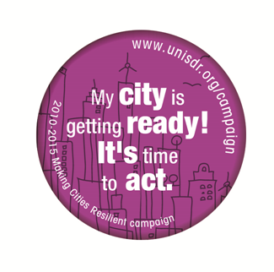
The British Council/DOST is committed to equal opportunities and diversity in all its activities and this includes the avoidance of any bias in the assessment of applications due to gender, disability, racial or ethnic origin, sexual orientation, or religious belief. Participants’ selection undertaken by workshop organisers must not contravene this policy. Extra support to enable participation of early career researchers with special needs will be given.
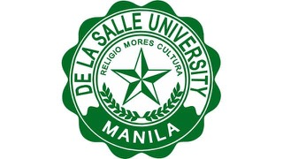
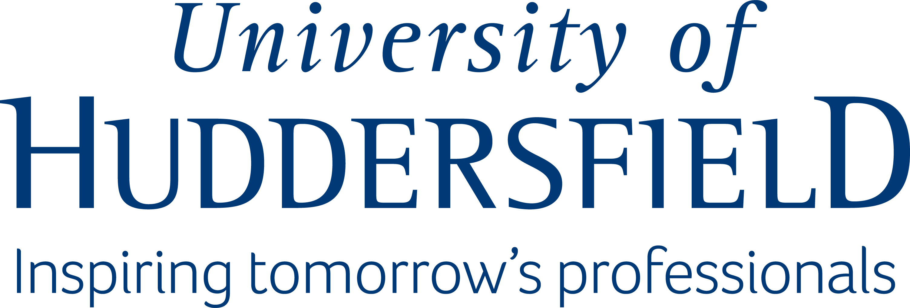
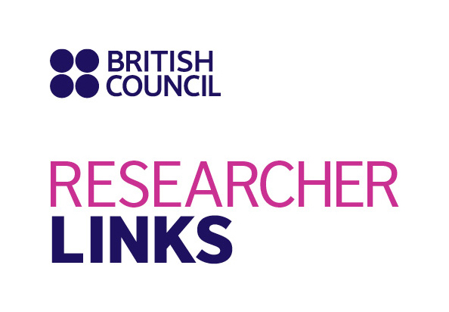

Application Form

1. Applicant

Name and title
Gender (to monitor statistic participation – this will not be considered during assessment)
Position and institution
Postal address
Email
Phone number
Brief CV (academic career, publications, markers of esteem, and any other relevant information) – no more than ½ page of A4

2. Title of abstract / presentation

Specify which Essential among the 10 E is most related to your research or work

- Abstract - Please give a summary of your research (maximum 500 words)

- Please describe your motivation to attend the workshop and how the workshop matches your professional development needs (maximum 300 words)

- Please describe the expected impact of your participation to the workshop on your personal and professional development, including your ability to work on an international level (maximum 300 words)

- Please indicate how you will disseminate the outcomes of the workshops and the new knowledge/skills you have acquired (maximum 300 words)

- Workshops will take place in English as standard. Please indicate your ability to work and communicate in English (Note, translators may be provided if necessary)
Native speaker |  | Good
Excellent |  | Need support

- Please use this space to give any additional information that you feel is relevant for the application
(maximum 300 words)

