Guide to Using LMI for Course Validation
Why is Labour Market Information (LMI) important?
To achieve the University’s commitment to ‘inspiring global professionals’ courses need to be informed by a good understanding of the world of work that our students will enter when they graduate. Reliable LMI provides an objective basis for this. Knowing the typical graduate outcomes enables course teams to consider how the curriculum develops the right knowledge, skills and experiences. Seeing how their course is relevant to life after university helps motivate students and gives them the confidence they can succeed. LMI therefore forms a vital part of Course Validation, Annual Evaluation and Subject Review.

Introduction
For Course Validation (PSD) you have to address two employability requests that require using LMI. These are:
- … demonstrate how the LTA strategy prepares students for relevant graduate outcomes. This section of the PSD should: identify the main occupations which are representative of the typical graduate outcomes for the course and identify the specialised and common skills needed for these by attaching the reports used for the Marketing Statement; address the ways in which the LTA strategy (including reference to specific modules, or assessments) prepares students for these graduate careers (including, where applicable, self-employment,) with the skills, knowledge and experiences required.
- And using Appendix 4, show how careers education supports this and contributes to the PDP requirement….
This Guide provides advice and guidance on how to answer these questions. The Appendix uses a fictional proposed degree in English as a worked example.
For the PSD you are asked | You should refer to | Information you can use | How these help / how to use them
- … demonstrate how the LTA strategy prepares students for relevant graduate outcomes. This section of the PSD should: identify the main occupations which are representative of the typical graduate outcomes for the course and identify the specialised and common skills needed for these by attaching the reports used for the Marketing Statement; address the ways in which the LTA strategy (including reference to specific modules, or assessments) prepares students for these graduate careers (including, where applicable, self-employment,) with the skills, knowledge and experiences required | What types of graduate careers would this course lead to? Identify around 10 that are representative of likely outcomes. Use one of more of the following as required:  - What Do Graduates Do?  - What Can I Do With My Degree?  - Graduate Outcomes data from the University of Huddersfield as shown in Apollo.  - Lightcast Report using JACS Codes  - Options with My Degree (from UoH Careers Service). | If you have completed a Marketing Statement for your new course proposals, you will have identified the typical graduate occupations for your course.  If you have not completed a Marketing Statement, please see the separate Guide to this. | When completing your PSD, you can simply refer back to and draw on the Lightcast reports you produced for your Marketing Statement when considering this part of the PSD.  Please include any Lightcast Reports as part of your Course rationale documentation.
 | Do you have any evidence that relevant graduate occupations are expanding? Provide a single Lightcast Occupational Comparison Report for the graduate careers which are most important for this course (this might be for all the typical outcomes or a key sub-set). | If you have completed a Marketing Statement for your new course proposals, you will have identified the expected changes in graduate occupations for your course.  If you have not completed a Marketing Statement, please see the separate Guide to this. | When completing your PSD, you can simply refer to and draw on the Lightcast reports produced for your Marketing Statement when considering this part of the PSD.  You may choose to draw on other sectoral reports from Sector Skills Councils, Professional Bodies etc.
 | To prepare students for relevant graduate outcomes (including, where applicable, self-employment), what specialised and common skills, knowledge and experiences should the course develop? | If you have completed a Course Rationale for your new course proposals, you will have already identified the skills needed.  If you have not completed a Course Rationale, please see the separate Guide to this. | You should draw on Lightcast Jobs Postings Analytics Report for each of the relevant graduate occupations identified, (and if relevant Prospects Jobs Profiles.
The Employability & Enterprise Resources SharePoint site has specialised reports in the Labour Market Information folder which you can draw on as appropriate.
https://hudac.sharepoint.com/sites/U92-INT-EmployabilityResources
The Future World of Work Global Trends pdf has links to advice on how to address employability through the subject curriculum (pages 43-46) which are relevent to this part of the PSD.
- …using Appendix 4, show how careers education supports this and contributes to the PDP requirement…. | In Appendix 4 you are guided through a simple process to: (a) identify things you have planned in your course that contribute to Personal Development Planning - PDP; (b) consider the employability context for your course; (c) say what sort of careers inputs are needed to support your students. | Appendix 4 identifies a range of resources to use.  The data gathering undertaken for the Marketing Statement and Course Rationale will provide most if not all of the background analysis needed for Appendix 4.

Appendix: A Worked Example for a Fictional Proposed English UG Degree
Please note the worked example illustrates possible ways of using the resources and is NOT a guide to the outcomes for the sample degree shown.
Question One: What types of graduate careers would this course lead to?

Use Prospects What Do Graduates Do? To identify the top 10 graduate Outcomes  https://graduatemarkettrends.cdn.prismic.io/graduatemarkettrends/8d0f5a43-fe6e-4b78-b710-4c22baa1db5e_what-do-graduates-do-2021-22.pdf | Prospects https://www.prospects.ac.uk/careers-advice/what-can-i-do-with-my-degree)
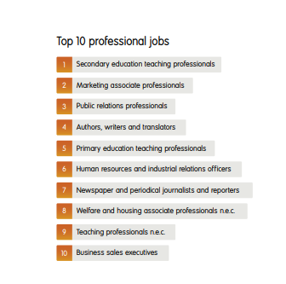
You could also look at Apollo for actual Graduate Outcomes from the University of Huddersfield. [NB. If you are doing this for a new course proposal, there may still be a similar course we have run which could provide relevant data, if carefully suitable interpreted] and Lightcast for national LMI derived data.
Apollo (NB. The search below covers English Studies, English Language and Linguistics etc.) | Lightcast (Jobs Posting report for English Studies JACS Q300). NB. The query identifies a range of occupations using the transferable skills from the degree and uses longitudinal data to identify occupations associated with holders of the degree. The initial long list must be narrowed to select the most likely occupations for new / recent graduates).
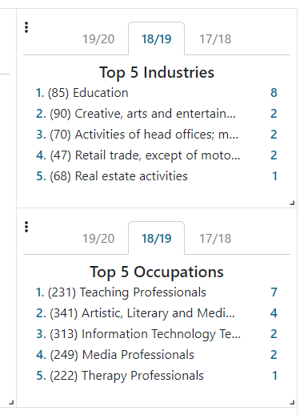 | 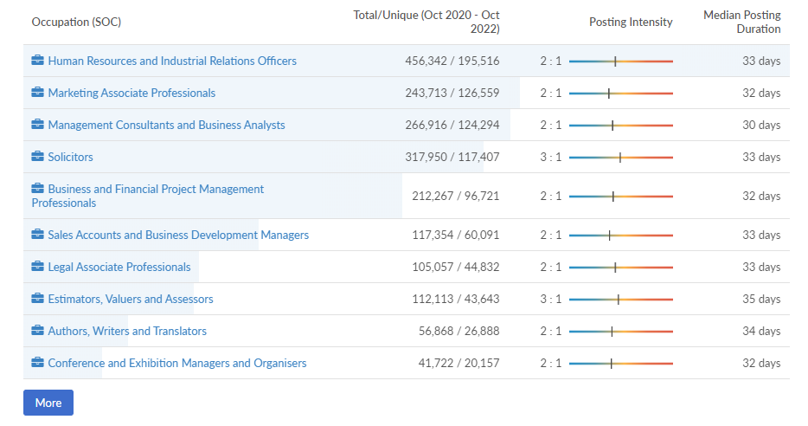

Drawing on national and local data these word docs provide a hand-picked picture of likely outcomes for our students covering around 40 discipline areas. [NB. There are bite sized video versions you can share with your students. Ask your Careers Consultant for more information.]
Options With My Degree | Options With My Degree
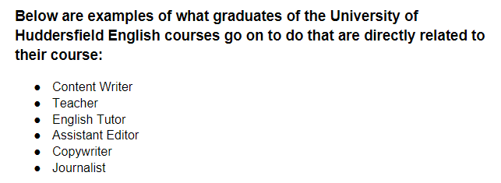 | 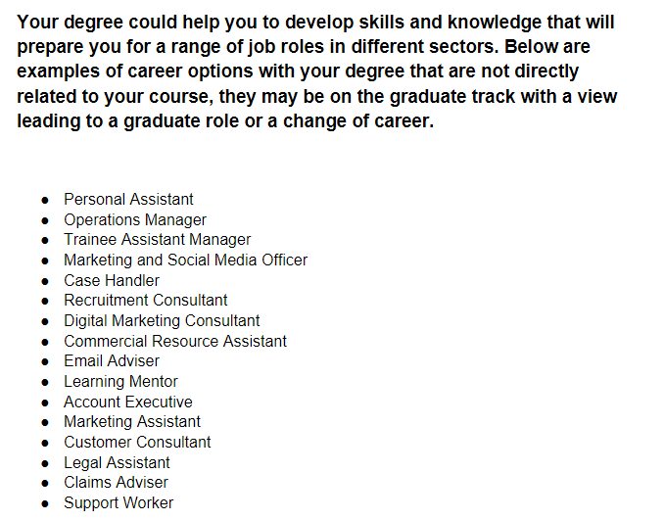
Next, drawing upon the various sources you have used, the course team decides which graduate occupations are most representative and useful for curriculum planning.
We would suggest around 10 occupations are selected to provide a manageable number as well as a representative spread. For some courses with a very specific vocation or professional focus the number may be smaller and restricted to occupations within the same sector or profession. NB the following selection is therefore purely illustrative.
Occupations selected (illustrative example). | Standard Occupational Classification Codes (SOC) are used by the UK Government to classify occupations by level. (while you do NOT need to state these, they have been provided for reference). SOC codes for Graduate Level / Highly Skilled occupations are ONLY those which start with a 1, 2 or 3. Please remember that Lightcast uses SOC 2010 version (as per historic ONS data sets). However, HESA and our Graduate Outcomes reports uses the newer SOC 2020 version.
Secondary Education Teaching | 2314
Marketing Associate Professionals | 3543
Public Relations Professionals | 2472
Authors, Writers and Translators | 3412
Primary Education Teaching Professionals | 2315
Human Resources and Industrial Relations Professionals | 3562
Newspaper and periodical journalist and reporters | 2471

By identifying the occupations representative of the degree outcomes the challenges and opportunities can be deliberately addressed in the course, through choice of topics, case studies, authentic assessment, live projects, placement opportunities and skills development etc. Having a specific set of careers to target helps to position students for these careers through ‘constructive alignment’ and at the same time develops transferable skills which can be applied to other more diverse degree relevant careers.

Question Two: Do you have any evidence that relevant graduate opportunities are expanding?

Your Lightcast Designated User will undertake the following search for you and provide you with the Occupational Comparison report. If you are creating this when proposing a new course, the Report should be sent to Marketing and attached to your to Marketing Statement. Remember that you will only need one Occupational Comparison report as the report can compare multiple occupations.
Please note regarding Lightcast, it is only Occupational reports that should be sent to Marketing. Please do NOT send Jobs Posting reports to Marketing.

Step 1: Meet your School’s Lightcast Designated User (DU) and discuss the selection of typical graduate outcomes you have chosen.

Step 2: DU Find the occupations by entering them into the search bar (shown below).
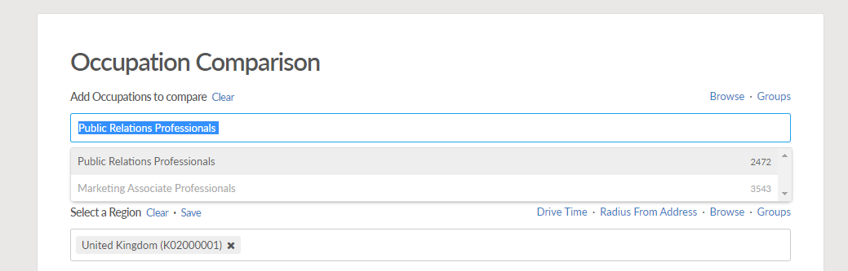

If a direct match is not available, use the Online CASCOT tool to find the best occupational match (and SOC code) and then create the and create a search. (NB if pasting text into the search bar Lightcast may not find any results if the text match is not an exact match. If this happens, try typing the start of the text descriptor instead). https://cascotweb.warwick.ac.uk/#/classification/soc2010 (NB currently Lightcast uses SOC 2010 version).

Step 3: Set the Region to the Leeds, Manchester and Sheffield LEP areas.

Step 4: Set the Timeframe to 5 years in the past and 5 years in the future.
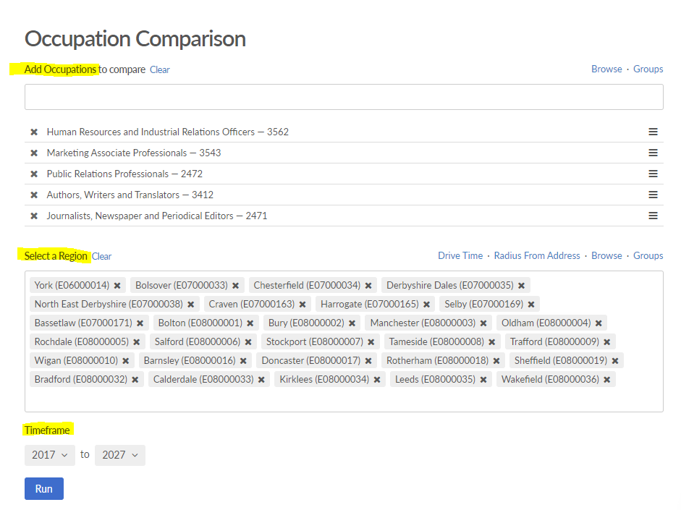
Step 5: Run the report, save in Lightcast and share as a pdf with the course team.
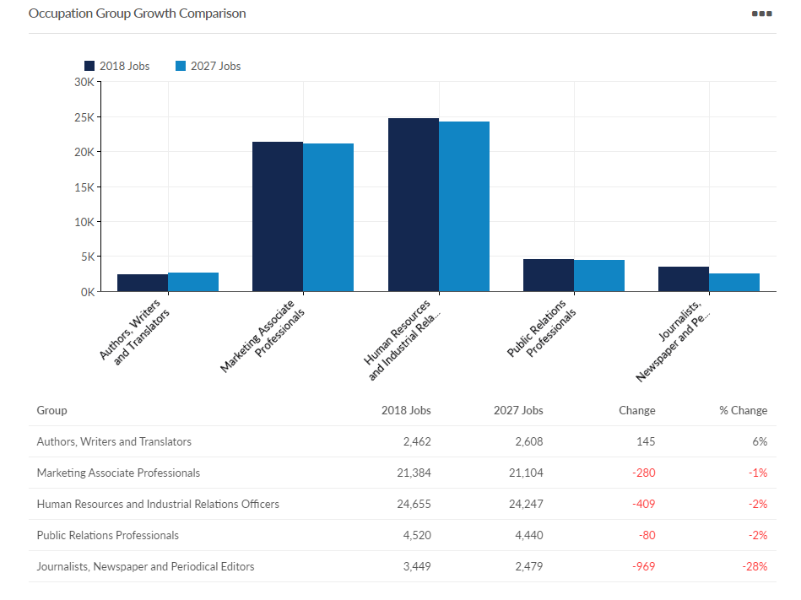

When viewing the results please bearing mind that:
- The historical occupational data is drawn from official UK government data sources and while no data is without potential issues this is the most reliable, objective and comprehensive data set possible.
- The results are for ‘occupational areas’ covering a range of occupations, including, but not limited to (new) graduate roles.
- Future data should be regarded as ‘trend-based projections’ rather than predictions.

You can use this data to answer questions like:
- What is the size of the different occupational areas compared to each other?
- Are there big differences in the number of opportunities in the region for the different occupations?
- Are there any outliers?
- Which is largest and which is smallest?
- Have any markedly expanded or declined recently?
- Are any projected to markedly expanded or declined in the near future?

Step 6: Optional Occupational Table Report

If the proposed course is heavily dependent upon a limited number of specialised occupations, and the Occupational Comparison Report indicates a possible (and significant) reduction in opportunities, then it is recommended that an Occupational Table Report is also produced for the occupations concerned to show in more detail the normal and projected number of openings (new jobs and vacancies created by ‘churn’). Please note that this is an optional element.

Question Three: To prepare students for relevant graduate outcomes (including, where applicable, self-employment), what specialised and common skills, knowledge and experiences should the course develop?

Step 7: Create Jobs Postings Analytics Reports
Your Lightcast Designated User will undertake the following searches for you and provide you with the Jobs Posting Analytics reports. To show the distinctive mix of skills needed, a separate report will be needed for each of the occupations identified by the course team as being especially important.

Step 8: Set the region to Leeds, Manchester and Sheffield LEP areas, unless your course as a different demographic.
Step 9: Set the time frame to the last 12 months to ensure that results reflect the current labour market.
Step 10: Run the report, save in Lightcast and share as a pdf with the course team.
Example snip from Jobs Postings Analytics Report: Journalist, Newspapers and Periodical Editors.
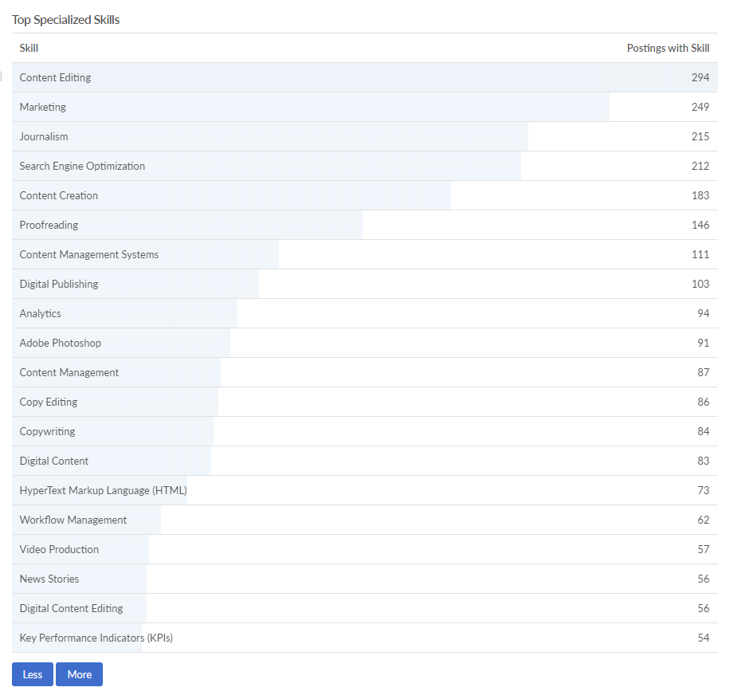 | 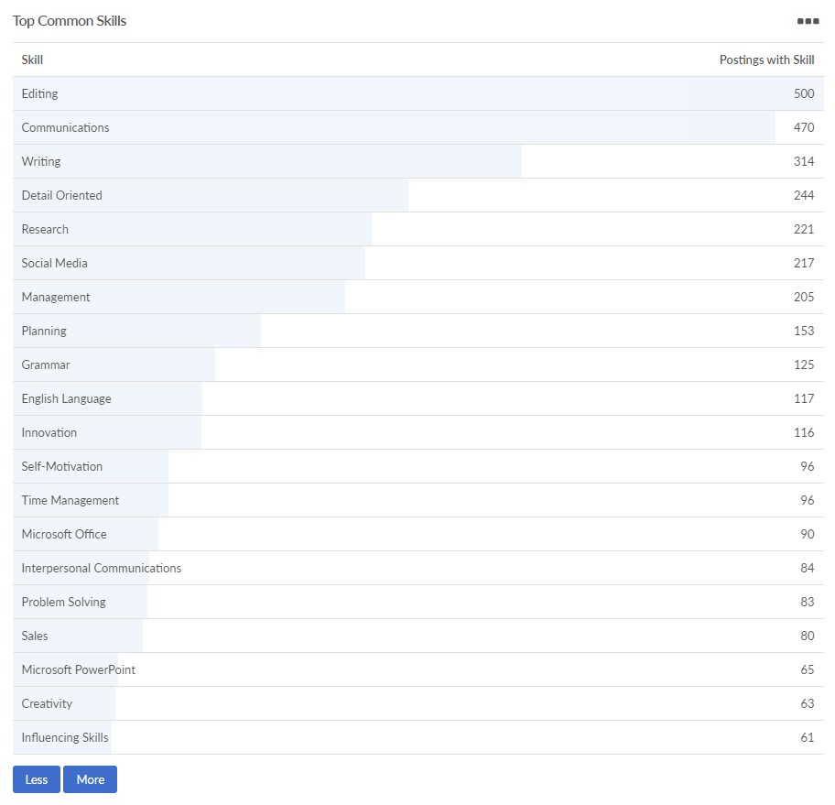
Doc created: 17/11/2022

