Appendix 4 Personal Development Planning (PDP)
What do you need to do for PDP?
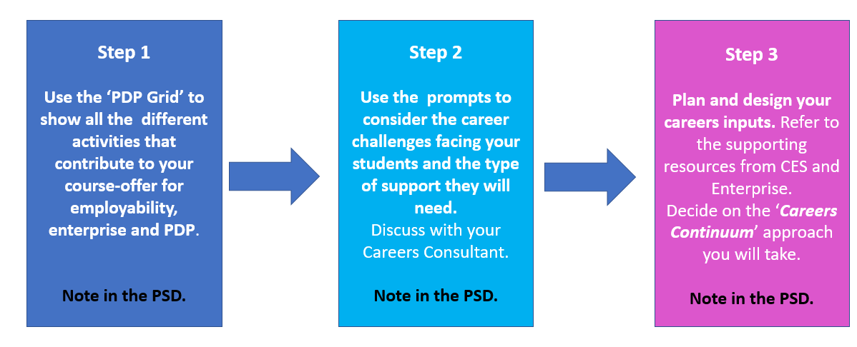
Step 1: The PDP Grid
All courses will naturally do a lot to support PDP. The Mapping Grid is a simple way of:
- Recognising and validating the activities contributing to PDP;
- Identify additional steps which might be taken.
Check those that you will build into your course offer.
PDP Outcomes | In the timetable / curriculum | School based provision | Extra-curricular  Indicate any you will take special steps to promote or include
Reflective learning  Career Planning  Personal Growth | [ ] ‘Career content’ in course  [ ] Huddersfield Graduate Attributes in the curriculum, mapped in MSD / PSD  [ ] GPA sessions  [ ] other employability aspects embedded in the curriculum  [ ] Employability module(s)  [ ] Enterprise skills activities / modules  [ ] Work experience / live projects  [ ] Placement Unit inputs  [ ] Support using academic feedback  [ ] Reflective learning  [ ] Independent final year projects  […] Other activities to develop wellbeing, resilience, happiness etc.  [ ] Other | [ ] PAT meetings and group tutorials and resources  [ ] Other | […] Careers appointments  […] Careers Readiness Survey  […] Careers workshops  […] Careers events / fairs  [...] Careers website and JobShop  […] Disability workshops  […] Wellbeing workshops  […] Big White Wall  […] Enterprise workshops and special projects  [ ] SU Societies and training for officers  [ ] SU training  [ ] BAME initiatives  [ ] Other relevant online learning (eg LinkedIn Learning)  [ ] Employability Mentoring  [ ] Other

Step 2: Understand the employability challenges and opportunities
Consider these questions
Aspect | Reflective questions | Data Sources
The student body | - What challenges do your students face (e.g. demographic, educational, social and cultural capital)?  - How well do your students do with developing their career thinking and implementing their plans? | - Apollo (demographic data, differential attainment data, OfS benchmarks)  - Careers Readiness Questionnaire data  - NSS / HSS
Progression | - Does the subject lead to a low or high proportion of students getting graduate level careers / study?  - If the GO results are good, what do you need to do to maintain that strong performance?  - Are relevant opportunities expanding or contracting nationally, or geographically localised?  - Are relevant opportunities well-advertised or part of the ‘hidden’ jobs market?  - Are relevant occupational routes complex and hard to navigate?  - Are relevant opportunities characterised by short term contracts, portfolio working, self-employment / freelancing etc.? | - Apollo (Graduate Outcomes)  - Prospects: What Can I Do With My Degree in…? https://www.prospects.ac.uk/careers-advice/what-can-i-do-with-my-degree  - Luminate: What Do Graduates Do? https://luminate.prospects.ac.uk/what-do-graduates-do  - Options with My Degree  - As a first step, please refer to the reports needed for the Marketing Report and Course Rationale  - Lightcast labour market information.  - Your SEEP (School Enterprise & Employability Plan)  - Sector Reports, professional bodies, and Sector Skills Councils.  - Employer networks.
The curriculum (content, teaching and assessment) | - What careers inputs / issues are already included in the modules?  - How could discipline issues and methodologies enable careers issues to be addressed?  - What new approaches might we introduce to increase student confidence and engagement?  - How could we work with employers and professional bodies to improve the curriculum? | Future World of Work Global Trends from the CES: Employability Resources INT - Home (sharepoint.com)  You can get ideas on employers to work with from your School Enterprise & Employability Group (SEEG), your Careers Consultant, the CES Business Partnership Team and your School’s Placement Unit.

Where possible you are encouraged to discuss the above with your School’s Careers Consultant

Step 3: Plan and design careers support
Reflecting upon questions 1 and 2, what sort of careers and PDP support is needed for your course?
Because one size doesn’t fit all, we have shown below how career inputs range along a continuum (1-5, with 1 being least intensive and 5 being the most intensive).
Career Inputs Intensity
1 2 3 4 5

Signposting | Targeted | Embedded
Approach | Approach | Approach
Raising awareness of the actions students should take and support available through info and comms at key points (mainly information and sign-posting; few, if any learning activities). | Course relevant careers inputs (information and learning activities) each year in curriculum (in module or in programme, e.g. consolidation week) | A planned, tailored and substantial programme of activities and info / comms in each year delivered mainly via dedicated space in (core) modules with credits attached.

Record the number (1-5) from the Careers Continuum which best corresponds to type of careers content you want to provide for your students. [NB this expresses an intention which can be revised later if required].

Obviously, this is the start of an ongoing process to plan your careers and PDP inputs. We recommend that you talk to your Careers Consultant about this (and the Enterprise Team) who can tell you about the resources we have made to help Lectures with employability, enterprise and PDP in the University-wide Employability Resources SharePoint site. Employability Resources INT - Home (sharepoint.com)

If you would like to know more about the University’s approach to PDP, please see the PDP Guide from CES.

