External member of University Council
Applicant Recruitment Pack



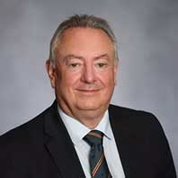
Dear Applicant
The University of Huddersfield is an amazing institution, taking its students on life changing journeys and providing a working environment where our colleagues can achieve career success and personal accomplishment. Originally from Huddersfield and having graduated in Engineering here, I am proud to lead this institution.
Here at the University of Huddersfield, we have a lot of which to be proud, including collaborative research with some of the top universities in the world. We were the first University to receive the Global Teaching Excellence Award and achieved the TEF Gold Award. We have transformed our academic workforce and are now ranked in the top five for the percentage of academic staff with a higher degree and have set the expectation that all academic staff have doctorates and publish at least at an international level. We take leadership seriously and now are the first organisation in the world where all members of the Senior Leadership Team are Chartered Managers. This commitment to transformational leadership is underpinning our drive towards becoming a global University.
We have won numerous awards including University of the Year, Entrepreneurial University of the Year, Best University workplace, the Queen’s Award for Enterprise and three national honours in the form of Queen’s Anniversary Prizes.
We are a highly sustainable organisation and placed amongst the top 10 in the UK for financial sustainability, with no historic debt. As such we have been able to invest more than £150m over the last ten years in a top-class estate and facilities.
The University is governed by its University Council, the principal decision-making body which approves the University Strategy and works to ensure that the Executive achieve the ambitions for Huddersfield and that the organise operates within sound governance structures.
University Council operates effectively as measured by independent external scrutiny and we welcome new members who can contribute to the continued high performance of Council and the success of the University.
Yours sincerely
Professor Bob Cryan CBE DL
Vice-Chancellor

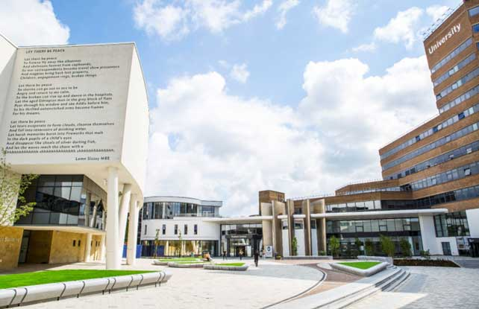

University of Huddersfield – Key facts
Here are some key facts that make the University of Huddersfield a great place to be.

Great learning

• We’re in the top 10 in England for the number of students going on placement (HESA Student Record 2023/2024).
• 100% of our undergraduate students have the opportunity to undertake professional work-related experience during their studies. This includes placements, industry standard projects and real-world case studies.*

Great teaching

• The University of Huddersfield has been rated Gold in the Teaching Excellence Framework (TEF) 2023. This means that the student experience and student outcomes are typically outstanding. These ratings were awarded in 2023, for four years.
These ratings reflect the University’s unwavering commitment to providing an exceptional student experience and fostering excellent student outcomes.
• In 2017, the University won the first Global Teaching Excellence Award recognising the University’s commitment to world-class teaching and its success in developing students as independent learners and critical thinkers (Higher Education Academy).
• Our staff rank first in England for the proportion with higher degrees and teaching qualifications, as well as being top five for those holding doctorates (HESA 2025).
• 24 of our colleagues have received National Teaching Fellowship awards since 2008, a figure matched by only one other University.
• Huddersfield is the only University where 100% of the permanent teaching staff are Fellows of the Higher Education Academy** (November 2020).

* This applies to undergraduate courses of more than 12 months duration.
** Permanent staff, after probation: some recently appointed colleagues will only obtain recognition in the months after their arrival in Huddersfield, once they have started teaching; research.

Great future

- 94% of our undergraduate students go on to work and/or further study within fifteen months of graduating (HESA Graduate Outcomes 2022/23, UK domiciled, other activities excluded).

- 98% of our postgraduate students go on to work and/or further study within fifteen months of graduating (HESA Graduate Outcomes 2022/23, UK domiciled, other activities excluded).

Research and innovation

- We’ve world-leading applied research groups in biomedical sciences, engineering and physical sciences, social sciences and arts and humanities.

- We’re a dynamic institution that has quadrupled our research income and its postgraduate research in seven years.

Customer service

- Our Library was the first to gain the UK National Customer Service Excellence Award and is the holder of eight marks of distinction.



Award-winning

- Queen’s Anniversary Prize (2021)

- Queen’s Anniversary Prize (2019)

- A gold-rated University (TEF 2023)

- Global Teaching Excellence Award (HEA 2017)

- Queen’s Anniversary Prize (2015)

- New University of the Year (Educate North 2015)

- Athena SWAN Bronze Award (2015, 2020,2022)

- We are a five star University (QS awards 2020,2023)

- University of the Year (Times Higher Education 2013)

- Entrepreneurial University of the Year
(Times Higher Education 2012)

- Queen’s Award for Enterprise
(International Trade 2013)

- Guardian Education Awards
(Inspiring Leader 2013)

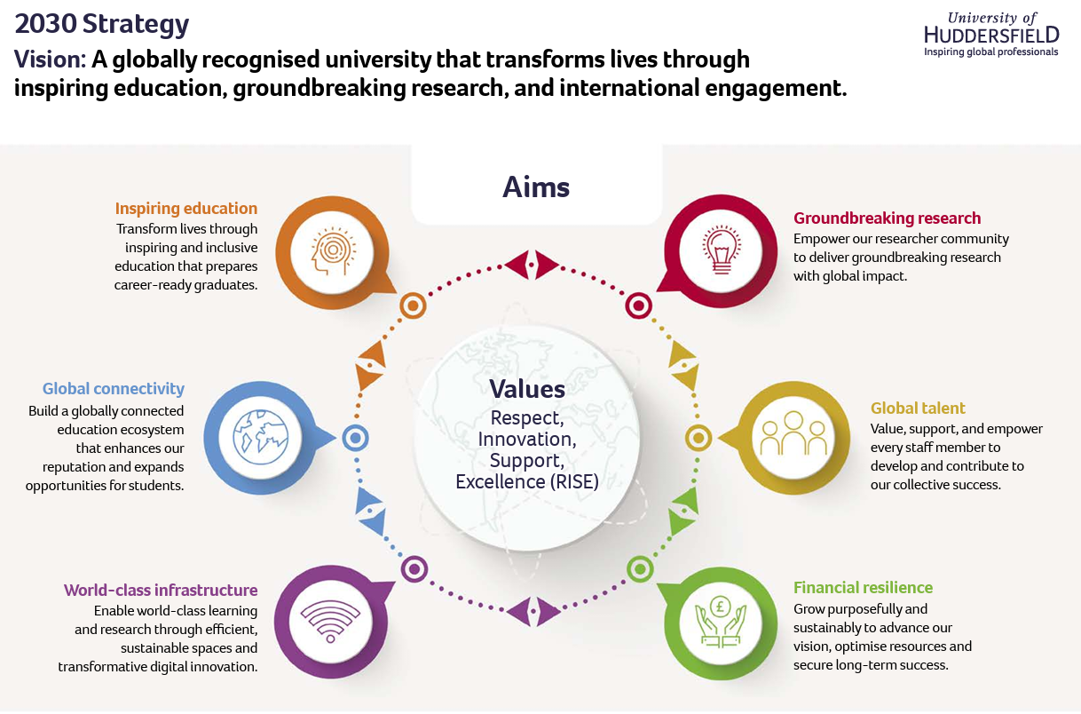



Equality, Diversity, Inclusion and Staff Networks

The University embraces and celebrates the diversity of our staff, students and applicants and works to ensure University policies, practices, procedures and projects are inclusive. Central to our strategy is inspiring and enabling all our students to succeed and we have committed to eliminating attainment gaps in degree outcomes, student continuation and graduate employment outcomes.
The University of Huddersfield is proud to have been accredited as a Disability Confident Leader, building on our previous accreditation as a Level 2 Disability Confident Employer.
The University has a number of staff networks which provide an opportunity for staff who share a protected characteristic to network, obtain peer support and share information. Our networks include the following:

  - LGBTQI+ Staff Network
  - Race Equity Staff Network and Affinity Groups
  - Staff Disability Network and Neurodiversity Group
  - Women’s Staff Network
  - Inclusive Allies Staff Network

Further information on the staff networks detailed above can be found on our Equality, Diversity and Inclusion web pages


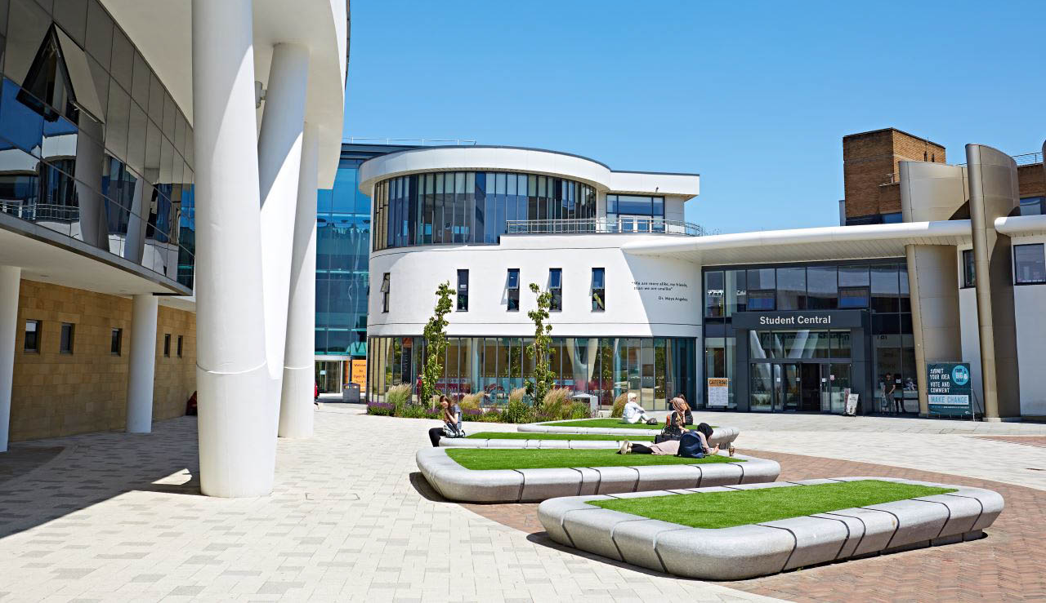

About the role
The University Council is the principal decision-making authority for the University. The membership of Council comprises a mix of ex officio, staff and student members and a majority of external members. Council is Chaired by an external member. The role of Council members is to ensure that the University has a sound strategy and to oversee its’ delivery; that the University remains financially sustainable and resilient; that risk is properly evaluated and manged by the Executive; and that the University operates within all relevant legal and regulatory requirements.
We are seeking a new external member of Council to work with us in this delivery. We are keen to continue to ensure that our Council remains diverse, representing the views and experiences of wide cross section of society and welcome expressions of interest from traditionally underrepresented groups.
This is an unremunerated post but with reasonable expenses covered. University Council has three formal meetings a year and two away days and we would also expect external members to sit on one of the Council sub-committees which meet three to four times a year.
If you would like further information, please contact Alison Jones at universitysecretary@hud.ac.uk
Application is by submission of a CV and a short covering letter setting out how you will contribute to the University to Alison Jones at the email address above.
Expressions of interest should be submitted 22 May 2026.



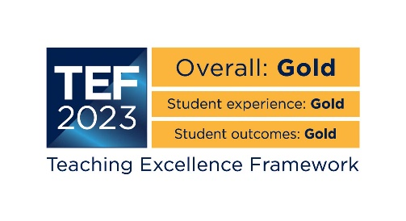 | 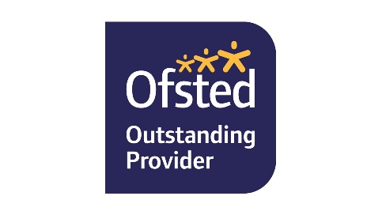 | 

