Scholarship Application Funding and Fees Guidance_2023/24
When you are ready to submit your application for scholarship you should select ‘how to apply/apply now’ from the scholarship webpage. You will then be guided to an online application form.
As you work through the various sections, there is additional information required that we will need you to provide in order for your application to be considered appropriately.
When you approach that funding/ fees section, please follow the instructions below.

- Funding/fees box
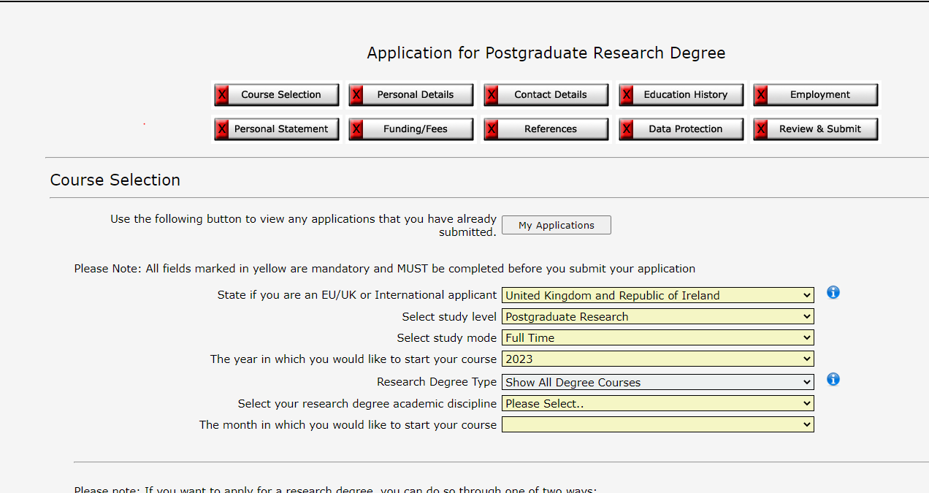

- Navigate to the ‘select fee payer’ field and from the drop-down menu, select ‘other source’.

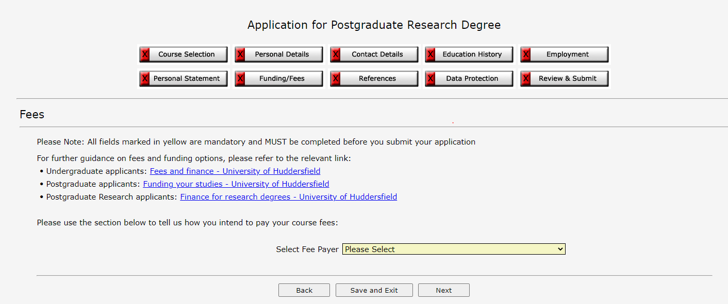

- Upon selecting ‘other source’ an additional free text box will appear.
Each scholarship type has a unique reference code, you can find the code on each scholarship advertisement. It is important that you indicate which scholarship/s you are applying for using both the reference code and the scholarship title (you will need to manually type this information into the box).
If you are applying for more than one scholarship, please ensure you indicate all of them within the free text box. An example is provided below.
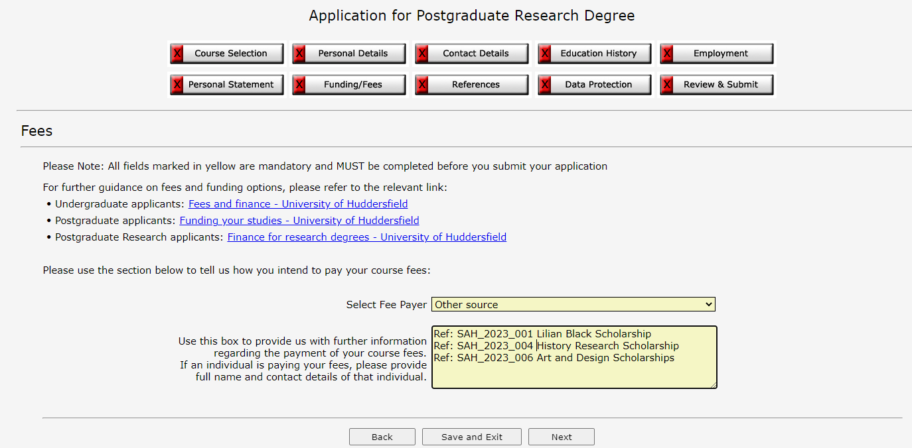
- Once you have indicated all the relevant scholarships, you are then able to progress towards application submission.

