Estates Online – Guidance
Estates Online can be accessed via the University Intranet.
Located in the column on the left-hand side of the main page (Estates Online-Planon)

Please follow the instructions provided on the page for logging in, especially if this is your first time.

When you log in, you will see the following sections.

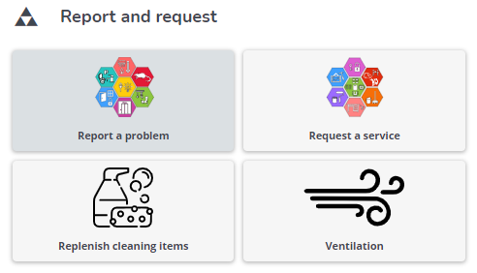

Report a Problem and Request a Service sections, when clicked on, will take you to another page with a list of job families. Each job family is broken down even further into specific templates for the most common requests for that type.

Please find below, a list of templates which fall under the sections ‘Report a Problem’ and ‘Request a Service’.

Report a Problem – Job Families

Request a Service – Job Families

The following sections take you direct to the specific template for that task.

Replenish Cleaning Items

Ventilation

When completing a template, you should:
- Ensure to include correct location details, including building, floor and room number.
- Enter details of who the request is on behalf of, if not yourself.
- Provide a cost centre (not required for all jobs) if requested on the template.
- Provide concise information in the job details.
  - Depending on what the job is, you may need to include additional information, such as but not limited to:
    - Start and finish times for set ups
    - Where items are located (please ensure anything is appropriated signed to make this easier for our colleagues, for example put a post it note on a table which is to be relocated.
    - Room layout required
    - If putting something up, where precisely is it to go and will it be signposted?
    - Advise of anything which may impact on staff being able to carry out works, such as room occupancy, etc.
The more information you can provide, the better it will be for our team members to complete the task to a satisfactory standard and in a reasonable time-frame.
- Upload any images as appropriate.

Recharges – some of our works will be re-chargeable to your service
- When completing the job, you will be ask to provide a cost centre.
- Once submitted, the job will go to the budget holder for approval.
Budget Holders will see any jobs on their ‘Action Required’ section on Estates Online.
- It is the responsibility of the requestor to ensure the budget holder is aware of the job and to know to access the system to approve.
- Please note – a job requiring a re-charge will not proceed until approval has been received via the system by the budget holder.
- As Cost Centres can change year on year, the Estates Online system may not be up to date. If your cost centre is not available, please note it in the Job Description section, and a member of our team will update our information and progress.

The Process:
- Once a job/request has been processed via Estates Online, a member of the Helpdesk Team will review the completed template to ensure all information required has been provided. Where there are gaps, we will contact the Requestor for this information and populate.
- We will then ‘Order Accept’ which will move the job along to sit on Planon and the Requestor will receive an automatic email confirming a request has been received.

Deadlines:

The Helpdesk team will raise works with external contractors.
ETAs from contractors will be requested and updated to the requestor.

Instant Response – some jobs will come through requiring an instant report (IR). These jobs are escalated as a matter of priority and have a response time of 2 hours.

Progress Updates
Please note – The Helpdesk are unable to provide updates on all For a progress update on your job/request – please email the Helpdesk who are more than happy to liaise with teams carrying out the works and will then confirm with yourselves.
Frequently Asked Questions:

Some categories are slightly ambiguous?
We have tried to make our system as user friendly as possible which meant limiting the amount of templates available to our customers – so where your feel your job doesn’t fit into one of the template available, please use the ‘Miscellaneous’ or ‘Other Service Fault’ to log.
We do monitor requests coming through and update templates accordingly.

I don’t know which job requires a budget code?
Templates are set up to request this information as appropriate, where one is not noted on the template, you can rightly assume that a cost centre is not required. If you are unsure, please email the Helpdesk prior to logging the request. The team will be more than happy to advise.

The collection room box does not let you specify the room number?
The collection room box comes under the Collect and Deliver job family.
When completing the Collection Location section, by clicking on the Blue Arrow, it will bring up a list of rooms within that building, for you to choose from.
If your room number is not listed, please contact the Helpdesk to advise, who will arrange for this information to be updated.
Room numbers can also be logged in the details section.

Sometimes its not easy to find what you are looking for?
Please use the search function under each Category. Use key words to find the most appropriate template for your request.
If you are still unsure, please contact the Helpdesk who are more than happy to assist.

More job categories are required, rather than using miscellaneous.
We have tried to keep the system straight forward by not over confusing with too many templates. Please do use the miscellaneous option. This will then come through and the experienced Helpdesk Team will then progress on the correct template using the back-office system, Planon.
Please note – this will not hold up progress of your request.

